TECHNICAL DATASHEET

Product Details

Code : SELMNHBW80
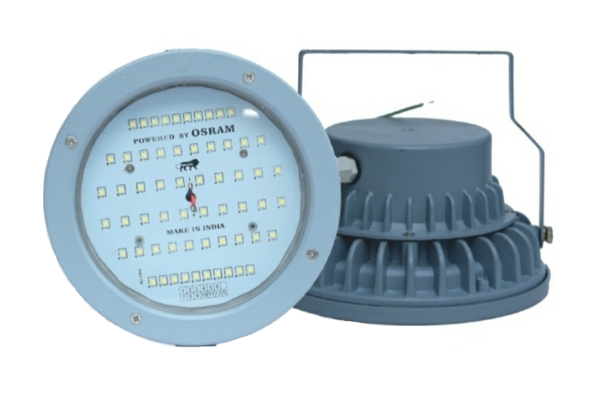
Series : LED High Bay Light
Model : Regular

Electrical Data

Input Voltage Range : 140 - 270 VAC
Power : 80 Watt
Power Factor : >0.95
Frequency : 50/60 Hz
Protections : THD < 10%
Driver : Constant Current Active
Power Factor Corrected
Lumens O/P : 10400 Lm

Light Data

LED Efficacy : 130 lm/Watt

Beam Angle : 120 ⁰
CCT : 5700 K +/- 500
CRI : >80
LED Make : Osram
LED Type : SMD LED
LED Life Time : 50,000 hours

Environmental

Working temperature : -20 to +50 Deg. Cel.
Working humidity : 10 to 90%
IP rating : IP66

Size

Dia x H : 185 x 50 mm

Applications

Manufacturing Plants, Shop Floor, Industrial Areas, Godown, Shops, Warehouses, Storage Units

